On the use of LiDAR at AmeriFlux sites
Summary of a White paper in progress
Martin Beland
Postdoc Fellow, Biometeorology lab
Department of Environmental Science, Policy and Management
University of California, Berkeley

LiDAR measurements can provide information about canopy structure, e.g., the vertical and horizontal organization of plant material, which is known to influence interactions between the atmosphere and the land surface. The aim of the white paper being prepared for AmeriFlux is to advise on the use of LiDAR technology for supporting research at AmeriFlux sites. Four types of LiDAR systems are considered: Airborne Laser Scanning (ALS), fixed-location Terrestrial Laser Scanning (TLS), the Portable Canopy LiDAR (PCL), and the Unstaffed Aerial Vehicle (UAV)-based LiDAR system (see Figure 1 for graphic descriptions of the systems).
In the fall of 2012 I conducted a survey to build a database on current LiDAR acquisitions over FLUXNET sites (see Table 1). It emerges that data is often not exploited to its full potential; a limited number of products are derived from each dataset, the data is rarely shared, and acquisitions are made for specific purposes while they could benefit a range of studies. It also emerges that the use of airborne LiDAR largely predominates the use of terrestrial LiDAR. One could argue that this is not due to airborne systems being better suited for supporting research at flux sites, but rather to the fact that from a user’s perspective the terrestrial systems require significantly more investment (both human and financial). Here we propose pathways to improve the strategic use of the different types of LiDAR systems at AmeriFlux sites.
In a general sense, the use of LiDAR data at AmeriFlux sites is expected to: (1) describe canopy structure (e.g., tree height, leaf distribution, biomass) locally for each site, and assess change in canopy structure through repeated samplings, (2) provide greater geometric detail for model hierarchy testing aimed at improving estimates of radiative transfer as used for photosynthesis and energy fluxes in models of land atmosphere interactions, which are the lower boundary condition for climate, carbon cycle and biogeochemical cycling models, (3) improve understanding of relations between spatial heterogeneity, or variability, and ecosystem dynamics, and (4) improve capacities to interpret fluxes locally, as well as upscale fluxes to global level. Some of the related sciences questions require canopy structure information over large areas, provided by airborne LiDAR systems, while other science questions may require a higher level of detail provided by terrestrial LiDAR systems.
The management context of AmeriFlux and the new generation of ecosystem manipulation experiments have implications which may influence the way LiDAR data is used at flux sites. First, AmeriFlux sites can share resources, which enables economies of scale in the acquisition and processing of LiDAR data. Second, manipulation experiments may shift information requirements from somewhat static descriptions of canopy structure to dynamic descriptions with shorter repeat intervals.
Given the above considerations and cost-benefits for each LiDAR system, I recommend the following:
(1) adopt a multi-scale LiDAR strategy (ground and airborne based) which would promote descriptions of canopy structure characteristics at appropriate scales for different science questions, as well as improve the quality of products derived from airborne sensors which are often based on empirical relations to simple measures like trunk diameters (DBH),
(2) invest in a terrestrial LiDAR instrument and recruit personnel dedicated to the acquisition, processing and sharing of LiDAR data for all AmeriFlux sites,
(3) invest in a Portable Canopy LiDAR and develop measurement protocols for taking advantage of the short repeat intervals it enables,
(4) promote the development of guidelines for the acquisition, processing, and sharing of all types of LiDAR data at flux sites, including emerging technologies like the UAV-based LiDAR system.

Airborne LiDAR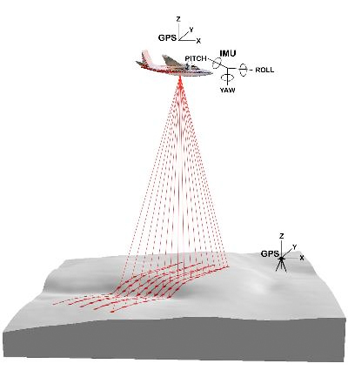 | Portable Canopy LiDAR  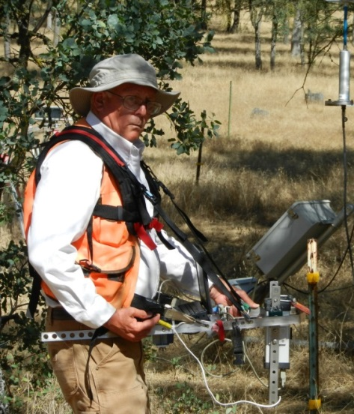
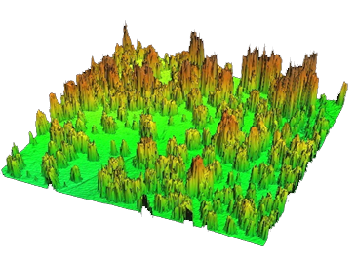 | 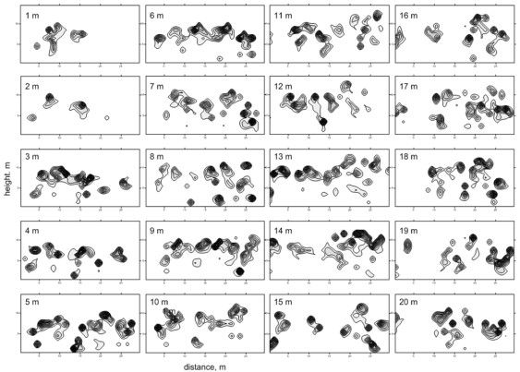
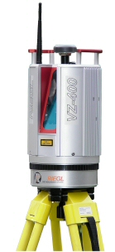 | 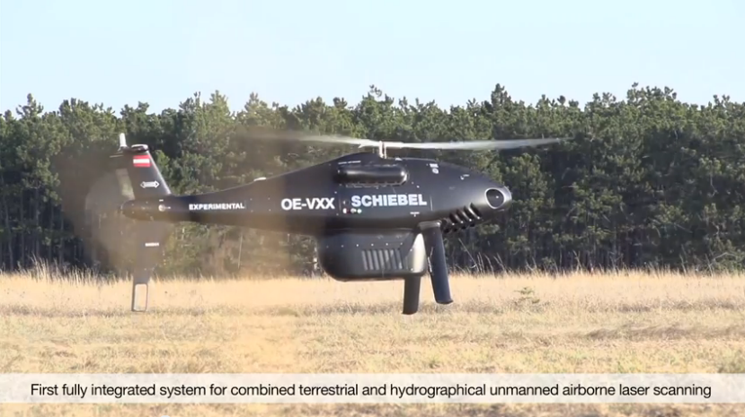
;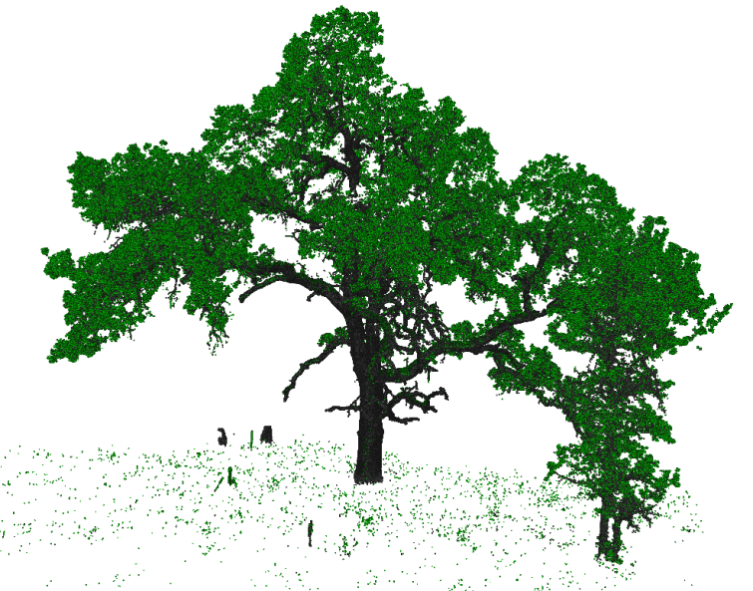  Terrestrial LiDAR | 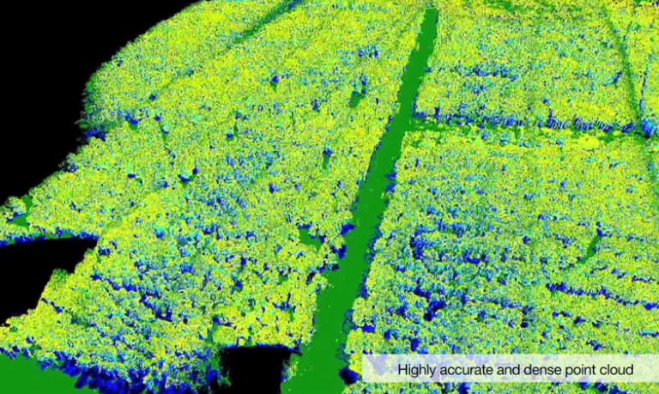  UAV-based LiDAR

Figure 1: Different LiDAR systems used in forests (some images from Riegl and UNAVCO)

Table 1: List of FLUXNET sites known to have Airborne LiDAR (ALS) data available as of September 2012. Sites with concomitant terrestrial LiDAR (TLS) data available are marked with an asterisk, and sites with Portable Canopy LiDAR (PCL) data are marked with †. Details on individual datasets is available at : http://nature.berkeley.edu/mbeland/FLUXNET_LiDAR/
Deciduous Broadleaf Forest | Mixed Forests, Deciduous Broadleaf
- Fontainebleau, France | - Bartlett Experimental Forest, NH, USA*
- Oak Openings, Ohio, USA | - Duke Forest, NC, USA†
- Silas Little Experimental Forest, New Jersey, USA*† | - Fichtelgebirge, Germany
 | - Hainich, Germany
- Smithsonian Environmental Research Center (SERC), MD, USA† | - Harvard Forest, Massachusetts, USA*†
 | - Laegeren, Switzerland*
- Willow Creek, Wisconsin, USA | - Park Falls, Wisconsin, USA
Evergreen Broadleaf Forest | Mixed Forests, Evergreen Needleleaf
- Tumbarumba, Australia | - Groundhog River, Canada*
- Wallaby Creek, Australia | - Loblolly Pine, NC, USA†
Evergreen Needleleaf Forest | - Weidenbrunnen, Germany
- Campbell River, B-C, Canada | Savannas and Shrublands
- Cedar Bridge, NJ, USA* | - Adelaide River, Australia
- GLEES, Wyoming, USA | - Daly River Savanna, Australia
- Howland Forest, Maine, USA* | - Dry river, Australia
- Hyytiala, Finland* | - Fogg Dam, Australia
- Lavarone, Italy | - Howard Springs, Australia
- Loobos, Netherlands* | - Las Majadas del Tietar, Spain*
- Metolius, Oregon, USA† | - Mata Seca, Brazil*
- Niwot Ridge, Colorado, USA* | - Santa Rosa National Park, Costa Rica*
- Renon/Ritten (Bolzano), Italy* | - Skukuza, South Africa*
- Wind River Crane Site, Washington, USA† | - Tonzi Ranch, CA, USA*†

